<-- instruction-->

**First, use SELECT * from both tables and use your knowledge of queries and aggregate functions to get to know the data:**

**What are the Top 25 schools (.edu domains)?**

**How many .edu learners are located in New York?**

**The mobile_app column contains either mobile-user or NULL. How many of these Codecademy learners are using the mobile app?**

SELECT email_domain,

COUNT(*)

FROM users

GROUP BY 1

ORDER BY 2 DESC

LIMIT 25;

SELECT city,

COUNT(*)

FROM users

WHERE city = "New York";

SELECT mobile_app,

COUNT(*)

FROM users

GROUP BY 1;

SELECT mobile_app,

100 * COUNT(mobile_app) / (SELECT COUNT(*) FROM users) as '%'

FROM users

GROUP BY 1;

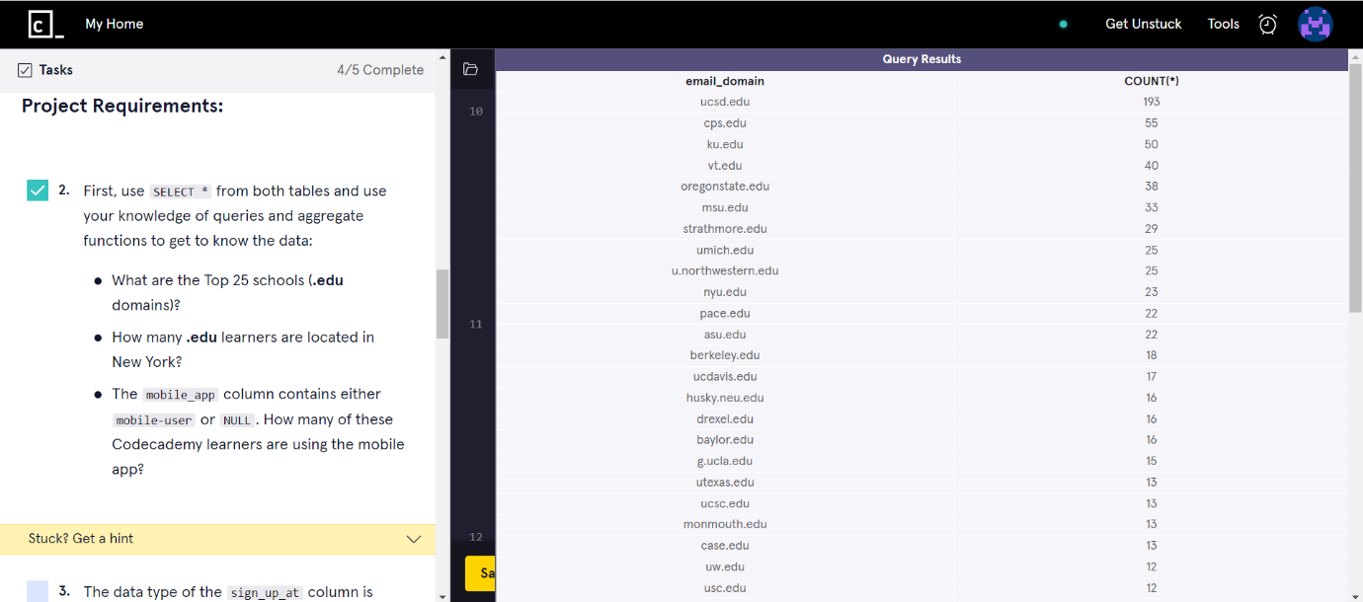

<-- instruction-->

**The data type of the sign_up_at column is DATETIME. It is for storing a date/time value in the database.**

**Notice that the values are formatted like:**

**2015-01-01 18:33:52**

**So the format is:**

**YYYY-MM-DD HH:MM:SS**

**SQLite comes with a strftime() function - a very powerful function that allows you to return a formatted date.**

**It takes two arguments:**

**strftime(format, column)**

**Let’s test this function out:**

**SELECT sign_up_at,**

**strftime('%S', sign_up_at)**

**FROM users**

**GROUP BY 1**

**LIMIT 20;**

**Now, using this function, query for the sign up counts for each hour.**

SELECT sign_up_at,

strftime('%S', sign_up_at)

FROM users

GROUP BY 1

LIMIT 20;

SELECT strftime('%H', sign_up_at),

COUNT(*)

FROM users

GROUP BY 1

ORDER BY 1;

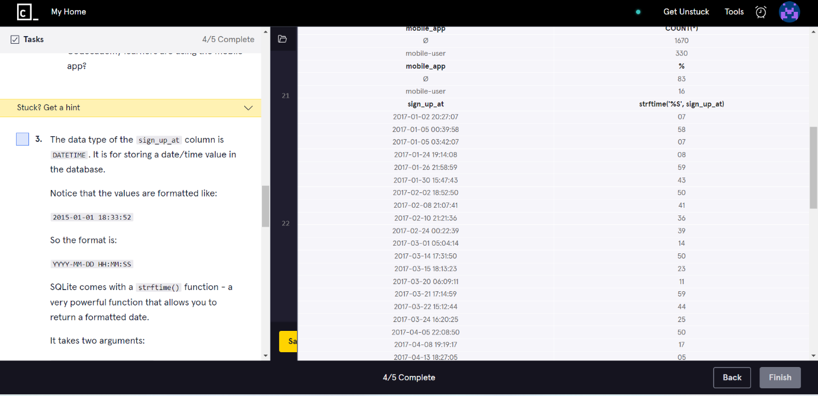

<-- instruction-->

**Join the two tables using JOIN and then see what you can dig out of the data!**

**Do different schools (.edu domains) prefer different courses?**

**What courses are the New Yorkers students taking?**

**What courses are the Chicago students taking?**

SELECT users.user_id,

users.email_domain,

users.city,

users.country,

progress.learn_cpp,

progress.learn_sql,

progress.learn_html,

progress.learn_javascript,

progress.learn_java

FROM users

JOIN progress

ON users.user_id = progress.user_id

LIMIT 10;

